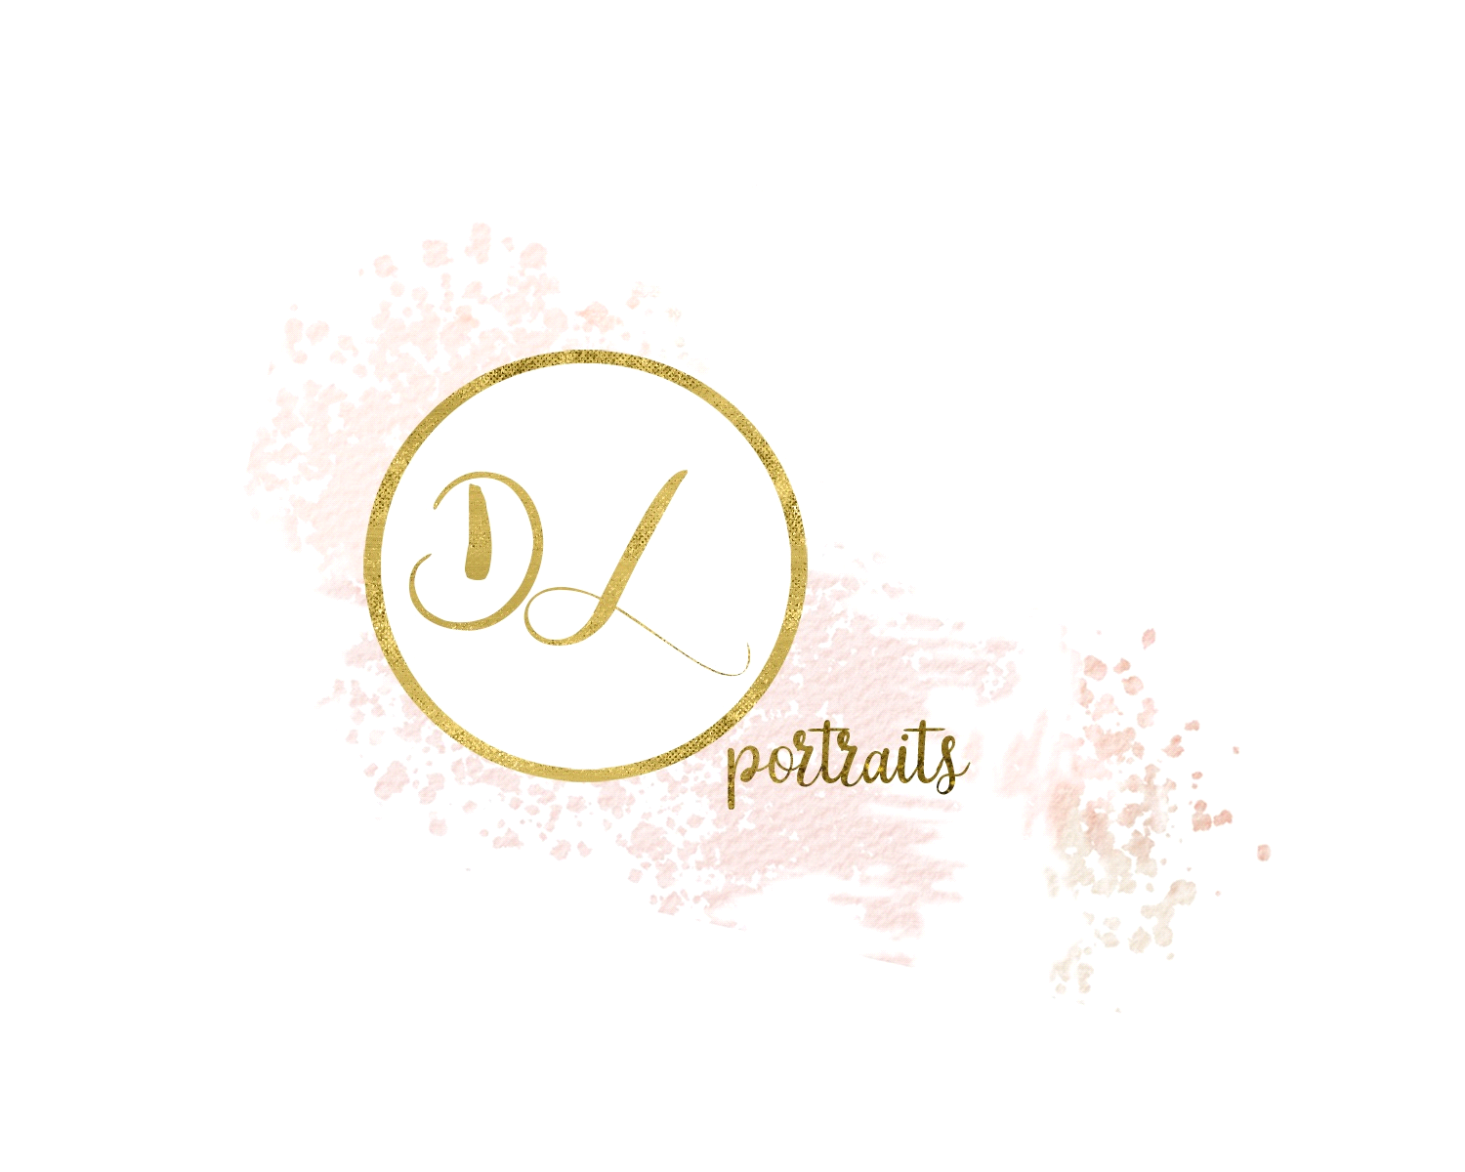
Pricing List

Family Session
$300 which includes
2-6 immediate family
Members (1- 1 ½ hours approx.)
In your home or pre-selected location
35 professionally edited,
digital images & online gallery
8 x 10 print provided
$100 deposit required

Cake Smash
$150 which includes
1hr session in studio
20 professionally edited, digital images and online gallery
$50 deposit required
*Cake/donuts must be brought to session due to allergie

Birthday Session
$200 which includes
50 professionally edited, digital images
And online gallery
- Images of birthday boy/girl
- Images with party guests
- Images with siblings and immediate family
- Cake images prior to “real cake time”
*images with extended family and their children are an extra $25 as this would be technically a family session*
- Back drop and props available upon request
*$75 Deposit required

Engagement/Anniversary
$250 which includes
1-2hr session (2people)
35 professionally edited,
digital images & online gallery
$100 deposit required

Christmas Mini Session
$150 which includes
20 min session (2-6 people)
15 professionally edited,
digital images & online gallery
$50 deposit required

Linkedin/Profile/Head Shots
$50 which includes
15min session
10 professionally edited,
digital images
$25 deposit

Branding Session
$350-$500 which includes
- A detailed phone interview, short questionnaire
- 100-150 professionally edited, digital images
- 3-4 different locations
- 4-8 different looks (head shots, work environment, coffee shop etc)
- Instagram makeover, refresh your feed with your new images and I will also help you with your hashtags
- Option to have an “always online gallery” available for a year after your session date
$150 deposit required

_______________________________________________________________
*All deposits are required at time of booking
*Sessions will be honoured due to cancellation due to poor weather conditions
*Rescheduling must be arranged a week prior to session date
*Option for prints and enlargements are available at an additional fee

